Chapter 8
Python for Data Analysis

NumPy
- Introduction to NumPy:

- NumPy stands for Numerical Python. Numpy is a Python library that performs numerical calculations.

- NumPy is very fast because it is written in the C programming language.

- NumPy is built on linear algebra. It’s about matrices and vectors and performing the mathematical calculations on them.

- The key concept in NumPy is the NumPy array data type. A NumPy array may have one or more dimensions:

    - One dimension arrays (1D) represent vectors.
    - Two-dimensional arrays (2D) represent matrices.
    - And higher dimensional arrays represent tensors.
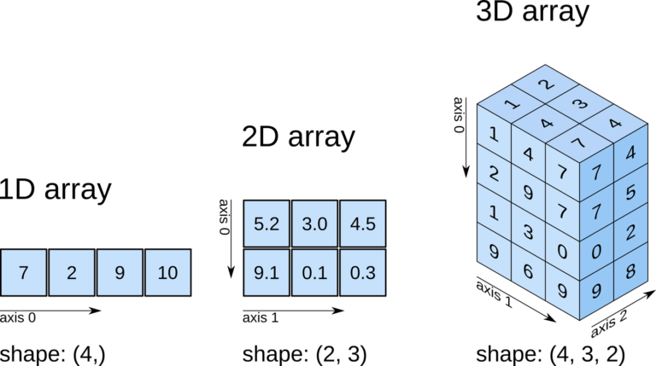

- Unlike the built-in list type that can hold the elements of different types, the NumPy arrays allow only one data type for all elements. Therefore, we say that the NumPy array requires homogeneous data values.
- A NumPy array can contain either integer or float numbers, but not both at the same time. This restriction allows Numpy to speed up the linear algebra calculations.
- NumPy supports basic operations such as average, minimum, maximum, standard deviation, variance, and many more.

- What is NumPy for:
NumPy is an important library for:
- Data Science
- Machine learning
- Signal and image processing
- Scientific and engineer computing

- Install NumPy
Since NumPy is a third-party package, we need to install it. To install NumPy, use the following pip command:
pip install numpy
- import NumPy as np
Once NumPy is installed successfully, we can import it to our program like this:
import numpy as np
Once you reference the NumPy module, we can use its functions and classes like creating a new array.
For example, the following creates a new NumPy array that contains three values:
a = np.array([1, 2, 3])
- Create NumPy Array:
The array is the core data structure of the NumPy library. A NumPy array is a grid of values with the same type and indexed by a tuple of non-negative integers.
All arrays are instances of the ndarray class. To create a new NumPy array, use the array() function of the NumPy library.
- Creating one-dimensional arrays:
The following example uses the array () function to create a one-dimensional (1-D) array:
Import numpy as np
a = np.array ([1, 2, 3])
print (type (a))
print (a)
Output:
<class 'numpy.ndarray'>
[1 2 3]
The array () function returns a new instance of the ndarray type. Therefore, the type (a) returns <class 'numpy.ndarray'>.
- A 1-D array is known as a vector.

- Getting the dimension of an array:
To get the number of dimensions of an array, you use the ndim property. In NumPy, dimensions are called axes. For example:
Import numpy as np
a = np.array ([1, 2, 3])
print (a.ndim)
Output:
1
In this example, the ndim property returns one as expected.

- Getting the data type of array elements:
To get the data type of the elements of an array, use the dtype property. For example:
import numpy as np
a = np.array([1, 2, 3])
print(a.dtype)
Output:
int32
In this example, the type of the elements is int32. If you want to set the type of the array’s elements, you can use the dtype argument of the array() function. For example:
import numpy as np
a = np.array([1, 2, 3], dtype=np.float64)
print(a)
print(a.dtype)
Output:
[1. 2. 3.]
float64
- Creating two-dimensional arrays
The following example uses the array() function to create a two-dimensional (2-D) array:
import numpy as np
b = np.array(
[
[1, 2, 3],
[4, 5, 6]
]
)
print(b)
print(b.ndim)
Output:
[[1 2 3]
[4 5 6]]
2

- In this example, we pass a list of a list of integers to the array() function. The ndim property returns 2 as expected.
- A good tip to get the number of dimensions of an array is that you count the square brackets ([) until you encounter the first number. The number of square brackets is the number of dimensions or axes.

- A two-dimensional array is also called a matrix.

- Creating three-dimensional array
The following example uses the array() function to create a three-dimensional (3-D) array:
import numpy as np

c = np.array(
[
[
[1, 2, 3],
[4, 5, 6]
],
[
[7, 8, 9],
[10, 11, 12]
],
]
)
print(c.ndim)
Output:
3
- Note that a 3-D array is also called a tensor.

- Getting shapes of arrays:
To find the number of axes and the number of elements on each axis of an array, you use the shape property. For example:
import numpy as np
a = np.array([1, 2, 3])
print(a.shape) # (3,)

b = np.array(
[
[1, 2, 3],
[4, 5, 6]
]
)
print(b.shape) # (2, 3)

c = np.array(
[
[
[1, 2, 3],
[4, 5, 6]
],
[
[7, 8, 9],
[10, 11, 12]
],
]
)
print(c.shape) # (2, 2, 3)
Output:
(3,)
(2, 3)
(2, 2, 3)
The shape property returns a tuple:
- The number of elements in the tuple is the number of axes.
- Each tuple element stores the number of elements of the corresponding axis.
- NumPy zeros():
The zeros() function of the numpy module allows you to create a numpy array of a given shape whose elements are filled with zeros.
For example, the following uses the zeros() function to create an array with two axes, the first axis has two elements and the second axis has three elements:
import numpy as np
a = np.zeros((2, 3))
print(a)
Output:
[[0. 0. 0.]
[0. 0. 0.]]
this example creates a 2-D array or a matrix that has two rows and three columns.
By default, zeros() function uses the type float64 for its elements. For example:
import numpy as np
a = np.zeros((2, 3))
print(a.dtype)
Output:
float64
To use a different type, you need to explicitly specify it in the zeros() function via the dtype argument. For example:
import numpy as np
a = np.zeros((2, 3), dtype=np.int32)
print(a)
print(a.dtype)
Output:
[[0 0 0]
[0 0 0]]
int32
In this example, we use int32 type for the elements. Hence, you don’t see the decimal point (.) in the output.
- NumPy ones():
The ones() function of the numpy module allows you to create a numpy array of a given shape whose elements are filled with ones.
For example, the following uses the ones() function to create an array with three axes, the first axis has two elements, the second axis has three elements, and the third axis has 4 elements:
import numpy as np
a = np.ones((2, 3, 2))
print(a)
Output:
[[[1. 1.]
[1. 1.]
[1. 1.]]

[[1. 1.]
[1. 1.]
[1. 1.]]]

By default, ones() function uses float64 for its elements. For example:
import numpy as np
a = np.ones((2, 3, 2))
print(a.dtype)
Output:
float64
To use a different type, you need to specify it using the dtype argument. For example:
import numpy as np
a = np.ones((2, 3, 4), dtype=np.int32)
print(a)
print(a.dtype)
Output:
[[[1 1]
[1 1]
[1 1]]

[[1 1]
[1 1]
[1 1]]]
int32
In this example, we use int32 type for the elements. Therefore, you don’t see the decimal point (.) appearing on each number.
- NumPy arange():
The numpy arange() function creates a new numpy array with evenly spaced numbers between start (inclusive) and stop (exclusive) with a given step:
numpy.arange(start, stop, step, dtype=None, *, like=None)
For example, the following uses arange() function to create a numpy array:
import numpy as np
a = np.arange(1, 10, 2)
print(a)
Output:
[1 3 5 7 9]
The numpy array starts at 1 and ends at 9. Note that it doesn’t include the stop ̣value (10). Because the step is 2, the numpy array contains 1, 3, 5, 7, and 9.
Because we pass 1 and 10 as integers, the arrange () function creates a new array of integers.
If you want to create an array of floats, you can pass the start and stop values as floats like this:
import numpy as np
a = np.arange(1.0, 10.0, 2)
print(a)
Output:
[1. 3. 5. 7. 9.]
Or you can explicitly specify the type of the numpy array’s elements using the dtype argument:
import numpy as np
a = np.arange(1, 10, 2, dtype=np.float64)
print(a)
Output:
[1. 3. 5. 7. 9.]
- numpy linspace() function:
The numpy linspace() function creates a new numpy array with evenly spaced numbers over a given interval:
numpy.linspace(start, stop, num=50, endpoint=True, retstep=False, dtype=None, axis=0)
The linspace() works like the arange() function. But instead of specifying the step size, it defines the number of elements in the interval between the start and stop values.
For example, the following uses the linspace() function to create a new array with five numbers between 1 and 2:
import numpy as np
a = np.linspace(1, 2, 5)
print(a)
Output:
[1. 1.25 1.5 1.75 2. ]
- NumPy Array Indexing:
Like a list, you can use the square bracket notation ([]) to access elements of a numpy array.
- NumPy array indexing on 1-D arrays
- Along a single axis, you can select elements using indices. The first element starts with index 0, the second element starts with index 1, and so on.
- Besides the non-negative indices, you can use negative indices to locate elements. For example, the last element has an index -1, the second last element has an index -2, and so on.
- The following example shows how to access elements of a one-dimensional array:
import numpy as np
a = np.arange(0, 5)
print(a)

print(a[0])
print(a[1])
print(a[-1])
Output:
[0 1 2 3 4]
0
1
4
- NumPy array indexing on 2-D arrays:
With 2-D and multidimensional arrays, you can select elements as you do with 1-D arrays but for each dimension (or axis). For example:
import numpy as np
a = np.array([
[1, 2, 3],
[4, 5, 6]
])
print(a.shape)
print(a[0]) # [1 2 3]
print(a[1]) # [4 5 6]
print(a[0, 0]) # 1
print(a[1, 0]) # 4
print(a[0, 2]) # 3
print(a[1, 2]) # 6
print(a[0, -1]) # 3
print(a[1, -1]) # 6
Output:
(2, 3)
[1 2 3]
[4 5 6]
1
4
3
6
3
6
- NumPy array indexing on 3-D arrays:
The following example creates a 3-D numpy array:

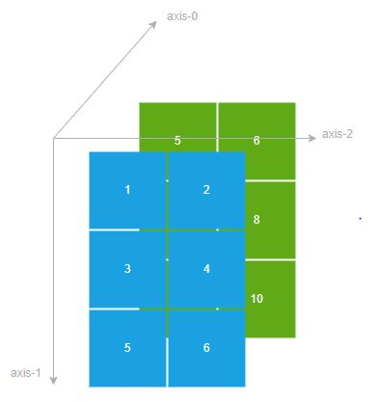

import numpy as np

a = np.array([
[[1, 2], [3, 4], [5, 6]],
[[5, 6], [7, 8], [9, 10]],
])

print(a.shape)
Output:
(2, 3, 2)
- Numpy Array Slicing

- Numpy array slicing on on-dimensional arrays:
NumPy arrays use brackets [] and : notations for slicing like lists. By using slices, you can select a range of elements in an array with the following syntax:
[m:n]
This slice selects elements starting with m and ending with n-1. Note that the nth element is not included.
- To select every two elements, you can use the following slice:
  - [m:n:2]
- In general, the following expression selects every k element between m and n:
  - [m:n:k]
If k is negative, the slice returns elements in reversed order starting from m to n+1. The following table illustrates the slicing expressions:

Slicing Expression | Meaning
a[m:n] | Select elements with an index starting at m and ending at n-1.
a[:] or a[0:-1] | Select all elements in a given axis
a[:n] | Select elements starting with index 0 and up to element with index n-1
a[m:] | Select elements starting with index m and up to the last element
a[m:-1] | Select elements starting with index m and up to the last element
a[m:n:k] | Select elements with index m through n (exclusive), with an increment k
a[::-1] | Select all elements in reverse order

See the following example:
import numpy as np
a = np.arange(0, 10)
print('a=', a)
print('a[2:5]=', a[2:5])
print('a[:]=', a[:])
print('a[0:-1]=', a[0:-1])
print('a[0:6]=', a[0:6])
print('a[7:]=', a[7:])
print('a[5:-1]=', a[5:-1])
print('a[0:5:2]=', a[0:5:2])
print('a[::-1]=', a[::-1])
Output:
a= [0 1 2 3 4 5 6 7 8 9]
a[2:5]= [2 3 4]
a[:]= [0 1 2 3 4 5 6 7 8 9]
a[0:-1]= [0 1 2 3 4 5 6 7 8]
a[0:6]= [0 1 2 3 4 5]
a[7:]= [7 8 9]
a[5:-1]= [5 6 7 8]
a[0:5:2]= [0 2 4]
a[::-1]= [9 8 7 6 5 4 3 2 1 0]

- Numpy array slicing on multidimensional arrays:
To slice a multidimensional array, you apply the square brackets [] and the : notation to each dimension (or axis). The slice returns a reduced array where each element matches the selection rules. For example:
import numpy as np
a = np.array([
[1, 2, 3],
[4, 5, 6],
[7, 8, 9]
])
print(a[0:2, :])

Output:
[[1 2 3]
[4 5 6]]
In this example, array a is a 2-D array. In the expression a[0:2, :]:
First, the 0:2 selects the element at index 0 and 1, not 2 that returns:
[[1 2 3]
[4 5 6]]
Then, the : select all elements. Therefore the whole expression returns:
[[1 2 3]
[4 5 6]]
Consider another example:
import numpy as np
a = np.array([
[1, 2, 3],
[4, 5, 6],
[7, 8, 9]
])
print(a[1:, 1:])
Output:
[[5 6]
[8 9]]
In the expression a[1:, 1:]:
First, 1: selects the elements starting at index 1 to the last element of the first axis (or row), which returns:
[[4 5 6]
[7 8 9]]
Second, 1: selects the elements starting at index 1 to the last elements of the second axis (or column), which returns:
[[5 6]
[8 9]]
- Introduction to the NumPy copy() method:
When you slice an array, you get a subarray. The subarray is a view of the original array. In other words, if you change elements in the subarray, the change will be reflected in the original array.
However, if you want a copy of an array rather than a view, you can use copy() method. For example:
import numpy as np
a = np.array([
[1, 2, 3],
[4, 5, 6]
])
# make a copy
b = a[0:, 0:2].copy()
print(b)
b[0, 0] = 0
print(b)
print(a)

In this example:
First, call the copy() method of array a to make a copy of a subarray and assign it to the variable b.
Second, change the element at index [0,0] of the array b, because both arrays are independent, the change doesn’t affect array a.

- Aggregate functions:

- numpy sum() function:
The numpy sum() function is an aggregate function that takes an array and returns the sum of all elements.
The following example uses the sum() function to calculate the sum of all elements of a 1-D array:
import numpy as np
a = np.array([1, 2, 3])
total = np.sum(a)
print(total)
Output:
6
The following example uses the sum() function to calculate the sum of all elements of a 2-D array:
import numpy as np
a = np.array([
[1, 2, 3],
[4, 5, 6]
])
total = np.sum(a)
print(total)
Output:
21
The sum() function also accepts the axis argument that allows you to return the sum of elements of an axis. For example:
import numpy as np
a = np.array([
[1, 2, 3],
[4, 5, 6]
])
total = np.sum(a, axis=0)
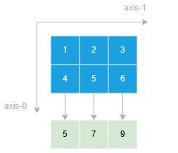
print(total)

Output:
[5 7 9]
In this example, the sum() function returns a new array where each element is the sum of elements of the array a on axis-0.
Similarly, you can sum elements on axis-1 like this:
import numpy as np
a = np.array([
[1, 2, 3],
[4, 5, 6]
])

total = np.sum(a, axis=1)
print(total)
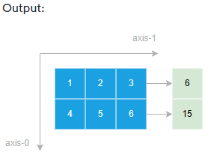

[ 6 15]
- Use the sum() function to get the sum of all elements of an array.
- Use the axis argument to specify the axis that you want to sum up.
- NumPy mean() function :
The mean() function returns the average of elements in an array. Here’s the syntax of the mean() function:
numpy.mean(a, axis=None)
In this syntax:
- a is an array that you want to calculate the average of elements.
- axis is the axis if specified will return the average of elements on that axis.
NumPy mean() function on 1-D array example
import numpy as np
a = np.array([1, 2, 3])
average = np.mean(a)
print(average)
Output:
2.0
NumPy mean() function on 2-D array example
import numpy as np
a = np.array([
[1, 2, 3],
[4, 5, 6]
])
average = np.mean(a, axis=0)
print(average)
Output:
[2.5 3.5 4.5]
- NumPy var() function:
The variance is a measure of the spread of a distribution. To manually calculate the variance of numbers, you follow these steps:
- First, calculate the average of all numbers.
- Second, calculate the squared difference of each number by subtracting it from the mean and square the result.
- Third, calculate the average of those squared differences.
For example, to calculate the variance of three numbers 1, 2, and 3:
First, calculate the average (or mean):
(1+2+3) / 3 = 2.0
Second, calculate the squared difference of each number with the mean:
(1-2)2 + (2-2)2 + (3-2)2 = 2
Third, calculate the average of these squared differences:
2 / 3 ~ 0.667
To calculate the variances of numbers in an array, you can use the var() function:
For example:
import numpy as np

a = np.array([1, 2, 3])
result = np.var(a)
print(round(result,3))
Output:
0.667
- NumPy std():
Standard deviation measures how spread out the elements of an array is. The more spread out elements is, the greater their standard deviation.
Standard deviation is the square root of the variance.

The following example uses the std() function to calculate the standard deviation
import numpy as np
diameters = np.array([591, 239, 210, 207, 201, 182,
176, 176, 175, 170, 170, 169, 168, ])
result = np.std(diameters)
print(round(result, 1))
- Use the numpy std() function to calculate the standard deviation.
- NumPy amin() function:
The amin() function returns the minimum element of an array or minimum element along an axis.

NumPy amin() function examples:

1) Using numpy amin() function on 1-D array example
import numpy as np

a = np.array([1, 2, 3])
min = np.amin(a)
print(min)
Output:
1

2) Using numpy amin() function on multidimensional array examples

The following example uses the amin() funciton to find the minimum number in a 2-D array:
import numpy as np
a = np.array([
[1, 2],
[3, 4]]
)
min = np.amin(a)
print(min)
Output:
1
If you want to find the minimum value on each axis, you can use the axis argument. For example, the following uses the amin() function to find the minimum value on axis 0:
import numpy as np
a = np.array([
[1, 2],
[3, 4]]
)
min = np.amin(a, axis=0)
print(min)

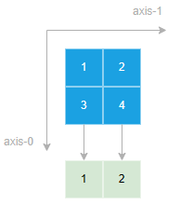
Output:
[1 2]
Similarly, you can use the amin() function to find the minimum value on axis 1:
import numpy as np
a = np.array([
[1, 2],
[3, 4]]
)
min = np.amin(a, axis=1)
print(min)

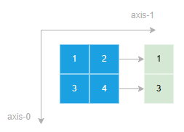

Output:
[1 3]

3) NumPy amax() function

The amax() function returns the maximum element of an array or maximum element along an axis. The following shows the syntax of the amax() function:
The following example uses the numpy amax() function to find the maximum value in a 1-D array:
import numpy as np
a = np.array([1, 2, 3])
min = np.amax(a)
print(max)
Output:
1

Using numpy amax() function on multidimensional array examples

The following example uses the amax() funciton to find the maximum number in a 2-D array:

import numpy as np

a = np.array([

[1, 2],

[3, 4]]

)

max = np.amax(a)

print(max)
Output:
1
If you want to find the maximum value on each axis, you can use the axis argument. For example, the following uses the amax() function to find the maximum value on axis 0:
import numpy as np
a = np.array([
[1, 2],
[3, 4]]
)
max = np.amax(a, axis=0)
print(max)

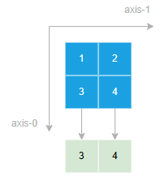
Output:
[3 4]
Similarly, you can use the amax() function to find the maximum value on axis 1:
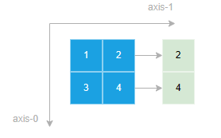
import numpy as np
a = np.array([
[1, 2],
[3, 4]]
)
max = np.amax(a, axis=1)
print(max)

Output:
[2 4]

- numpy any() function:
The numpy any() function returns True if any element in an array (or along a given axis) evaluates to True.

numpy any() function on 1-D array examples

The following example uses the any() function to test whether any number in an array are non-zero:

import numpy as np
result = np.any([0, 1, 2, 3])
print(result)
Output:
True
- numpy any() function with a multidimensional array example:
The following example uses the any() function to test if any elements of a multidimensional array evaluate to True:
import numpy as np
a = np.array([[0, 1], [2, 3]])
result = np.any(a)
print(result)
Output:
True

- Array operations:

- NumPy reshape():
The reshape() function changes the shape of an array without changing its elements. Here’s the syntax of the reshape() function:
numpy.reshape(a, newshape, order='C')
In this syntax, the reshape() function changes the shape of the array a to the newshape but keep the number of elements the same.
Using numpy reshape() function with 1-D array example
The following example uses the numpy reshape() function to change a 1-D array with 4 elements to a 2-D array:
import numpy as np
a = np.arange(1, 5)
print(a)
b = np.reshape(a, (2, 2))
print(b)
Output:
[1 2 3 4]
[[1 2]
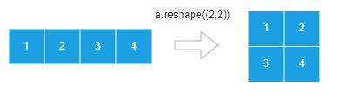
[3 4]]

- Numpy transpose() function:
The numpy transpose() function reverses the axes of an array. Here’s the syntax of the transpose() function:
numpy.transpose(a, axes=None)
In this syntax:
a is an input array. It can be a numpy array or any object that can be converted to a numpy array.
axes is a tuple or a list that contains a permutation of [0,1,..,N-1] where N is the number of axes of the array a.
The transpose() function returns the array a with its axes permuted.
Using transpose() function with 1-D array example
The following example uses the transpose() function with 1-D array:
import numpy as np
a = np.array([1, 2, 3])
b = np.transpose(a)
print(b)
Output:
[1 2 3]
The transpose() function has no effect on a 1-D array because a transposed vector is simply the same vector.
Using numpy transpose() function with 2-D array example
The following example uses the transpose() function to transpose a 2-D array (or a matrix):
import numpy as np
a = np.array([
[1, 2, 3],
[4, 5, 6]])
b = np.transpose(a)
print(b)
Output:
[[1 4]
[2 5]
[3 6]]
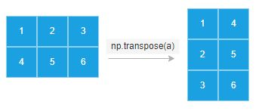

In this example, the transpose() function transpose a (2,3) array. Basically, it swaps rows and columns of the array.
After the transposition, the first row of array a becomes the first column of the transposed array b, the second row of array a becomes the second column of the transposed array b.

- NumPy sort() function:
The sort() function returns a sorted copy of an array. Here’s the syntax of the sort() function:
numpy.sort(a, axis=- 1, kind=None, order=None)

In this syntax:
- a is a numpy array to be sorted. Also, it can be any object that can be converted to an array.
- axis specifies the axis along which the elements will be sorted. If the axis is None, the function flattens the array before sorting. By default, the axis is -1 which sorts elements along the last axis.
- kind specifies the sorting algorithm which can be ‘quicksort’, ‘mergesort’, ‘heapsort’, and ‘stable’.
- order specifies which fields to compare first, second, etc when sorting an array with fields defined. The order can be a string that represents the field to sort or a list of strings that represent a list of fields to sort.
the sort() function to sort a 1-D array
import numpy as np
a = np.array([2, 3, 1])
b = np.sort(a)
print(b)
Output:
[1 2 3]
In this example, the sort() function sorts the elements of the array from low to high
To sort elements of an array from high to low, you can use the sort() function to sort an array from low to high and use a slice to reverse the array. For example:
import numpy as np
a = np.array([2, 3, 1])
b = np.sort(a)[::-1]
print(b)
Output:
[3 2 1]
In this example:
First, the sort() function sorts the elements in the array a in ascending order (from low to high)
Then, the slice [::-1] reverses the sorted array so that the elements of the result array are in descending order.
the numpy sort() function to sort a 2-D array example
The following example uses the sort() funciton to sort a 2-D array:
import numpy as np
a = np.array([
[2, 3, 1],
[5, 6, 4]
])
b = np.sort(a)
print(b)
Output:
[[1 2 3]
[4 5 6]]
The following example uses the sort() function to sort elements on axis 0:
import numpy as np

a = np.array([
[5, 3, 4],
[2, 6, 1]
])

b = np.sort(a, axis=0)
print(b)
Output:
[[2 3 1]
[5 6 4]]
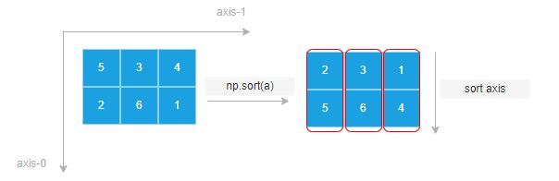

- Arithmetic operations:
1. Numpy add() function:
The + or add() function of two equal-sized arrays perform element-wise additions. It returns the sum of two arrays, element-wise.
NumPy add() function and + operator to add two 1D arrays example
The following example uses the + operator to add two 1-D arrays:
import numpy as np
a = np.array([1, 2])
b = np.array([2, 3])

c = a + b
print(c)
Output:
[3 5]
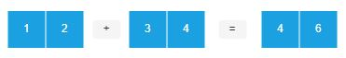

NumPy add() function and + operator to add two 2D arrays example
import numpy as np
a = np.array([[1, 2], [3, 4]])
b = np.array([[5, 6], [7, 8]])
c = a + b
print(c)
Output:
[[ 6 8]
[10 12]]
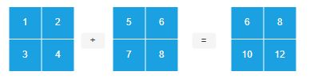

2. Numpy subtract() function:
The - or subtract() function returns the difference between two equal-sized arrays by performing element-wise subtractions.
The following example uses the - operator to find the difference between two 1-D arrays:
import numpy as np

a = np.array([1, 2])
b = np.array([3, 4])
c = b - a
print(c)
Output:
[2 2]
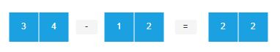

Similarly, you can use the subtract() function to find the difference between two 1D arrays like this:
import numpy as np
a = np.array([1, 2])
b = np.array([3, 4])
c = np.subtract(b, a)
print(c)
Output:
[2 2]
NumPy subtract function and – operator to find the difference between two 2D arrays example
import numpy as np
a = np.array([[1, 2], [3, 4]])
b = np.array([[5, 6], [7, 8]])
c = b - a
print(c)
Output:
[[4 4]
[4 4]]
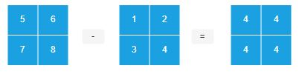

3. NumPy multiply()
The * operator or multiply() function returns the product of two equal-sized arrays by performing element-wise multiplication.
The following example uses the * operator to get the products of two 1-D arrays:
import numpy as np
a = np.array([1, 2])
b = np.array([3, 4])
c = a*b
print(c).
Output:
[3 8]
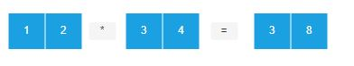

Similarly, you can use the multiply() function to get the product between two 1D arrays as follows:
import numpy as np
a = np.array([1, 2])
b = np.array([3, 4])
c = np.multiply(a, b)
print(c)
Output:
[3 8]
The following example uses the * operator to get the products of two 2D arrays:
import numpy as np
a = np.array([[1, 2], [3, 4]])
b = np.array([[5, 6], [7, 8]])
c = a*b
print(c)
Output:
[[ 5 12]
[21 32]]
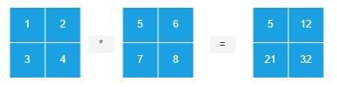

4. NumPy divide():
The / operator or divide() function returns the quotient of two equal-sized arrays by performing element-wise division.
The following example uses the / operator to find the quotient of two 1-D arrays:
import numpy as np
a = np.array([8, 6])
b = np.array([2, 3])
c = a/b
print(c)
Output:
[4. 2.]
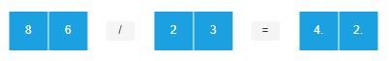

Similarly, you can use the divide() function to get the quotient of two 1D arrays as follows:

import numpy as np
a = np.array([8, 6])
b = np.array([2, 3])
c = np.divide(a, b)
print(c)
Output:
[4. 2.]

The following example uses the / operator to find the quotient of two 2D arrays:
import numpy as np
a = np.array([[10, 8], [6, 4]])
b = np.array([[5, 2], [2, 1]])
c = a/b
print(c)
Output:
[[2. 4.]
[3. 4.]]
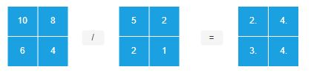

- NumPy concatenate():
The concatenate() function allows you to join two or more arrays into a single array. Here’s the basic syntax of the concatenate() function:
np.concatenate((a1,a2,...),axis=0)

In this syntax, the concatenate() function joins the elements of the sequence of arrays (a1, a2, …) into a single array. The arrays in the sequence must have the same shape.
The axis specifies the axis along which the funciton will join the arrays. If the axis is None, the function will flatten the arrays before joining.
Using the concatenate() function to join two 1D arrays
import numpy as np
a = np.array([1, 2])
b = np.array([3, 4])
c = np.concatenate((a, b))
print(c)

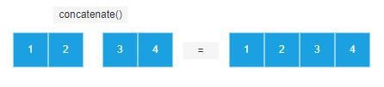

Output:
[1 2 3 4]
concatenate() function to join two 2D arrays

import numpy as np
a = np.array([
[1, 2],
[3, 4]
])
b = np.array([
[5, 6],
[7, 8]
])

c = np.concatenate((a, b))
print(c)
Output:
[[1 2]
[3 4]
[5 6]
[7 8]]
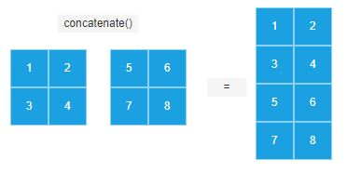

The output shows that the concatenate() function joins two arrays vertically because by default the axis argument is zero.
If the axis is one, the concatenate() funciton will join two arrays horizontally.

- NumPy split():

The split() funciton splits an array into multiple sub-arrays as views. The syntax of the split() function is as follows:
numpy.split(ary, indices_or_sections, axis=0)

In this syntax:

- ary is the array to be split into subarrays.

- indices_or_sections can be an integer or a 1-D array of sorted integers.

- If it is an integer, the function splits the input array into N equal arrays along the axis. If the split is not possible, the function will raise an error.

- If indices_or_sections is a 1D array of sorted integers, the indices indicate where along the axis the function splits the array.

- When an index exceeds the dimension of the array along the axis, the function returns an empty subarray.

- The following picture shows how the split() function splits the array with indices 2, 3, and 4. It results in 4 arrays.

Using the split() function to split a 1D array
The following example uses the split() function to split a 1D array with seven elements into three sub-arrays:

import numpy as np
a = np.arange(1,7)
results = np.split(a,3)
print(a)
print(results)
Output:
[1 2 3 4 5 6]
[array([1, 2]), array([3, 4]), array([5, 6])]
The following example raises an error because the split is not possible:
import numpy as np
a = np.arange(1,7)
results = np.split(a,4)
Output:
ValueError: array split does not result in an equal division
Using the split() function to split a 2D array
The following example uses the split() function to split a 2D array into two subarrays:
import numpy as np
a = np.array([[1,2],[3,4],[5,6],[7,8]])
results = np.split(a,2)
print(a)
print(results)
Output:
[[1 2]
[3 4]
[5 6]
[7 8]]
[array([[1, 2],
[3, 4]]), array([[5, 6],
[7, 8]])]

Some other useful functions:

    - Eye():
np.eye() is a NumPy function used to create a 2-dimensional array with ones on the diagonal and zeros elsewhere. Here's how you can use it:
import numpy as np
# Create a 2x2 identity matrix
identity_matrix_2x2 = np.eye(2)
print("2x2 Identity Matrix:")
print(identity_matrix_2x2)

# Create a 3x3 identity matrix
identity_matrix_3x3 = np.eye(3)
print("\n3x3 Identity Matrix:")
print(identity_matrix_3x3)
Output:
2x2 Identity Matrix:
[[1. 0.]
[0. 1.]]

3x3 Identity Matrix:
[[1. 0. 0.]
[0. 1. 0.]
[0. 0. 1.]]

  - np. random. random ( ):
np.random.random() is a NumPy function that generates random numbers from a uniform distribution over the range [0, 1).
import numpy as np
# Generate a single random number
random_number = np.random.random()
print("Random number between 0 and 1:", random_number)

# Generate an array of random numbers
random_array = np.random.random(5) # Generates 5 random numbers
print("\nArray of random numbers:")
print(random_array)

Output:
random number between 0 and 1: 0.46597256010370036
Array of random numbers:
[0.6096745 0.82371878 0.71866647 0.09698042 0.10245389]

3. Numpy Median():
The numpy.median() function calculates the median of an array along a specified axis. The median is the middle value of a sorted list of numbers. If the length of the array is odd, the median is the middle value. If the length is even, the median is the average of the two middle values.
import numpy as np
# Create an array
arr = np.array([1, 3, 5, 7, 9])
# Calculate the median of the array
median = np.median(arr)
print("Median of the array:", median)

Output:
Median of the array: 5.0
Explain universal array functions.
Universal functions (ufuncs) in NumPy are functions that operate element-wise on ndarrays. They are flexible and efficient tools for vectorized operations, which means they can perform computations on entire arrays without the need for explicit looping.
Overall, universal array functions in NumPy provide a powerful and efficient way to perform element-wise operations and aggregate computations on arrays, making them fundamental tools for numerical computing and data manipulation in Python.
Here are some key features of universal array functions:
- Element-wise operations: Ufuncs perform element-wise operations on arrays. This means that the operation is applied independently to each element of the input arrays.
- Vectorized computation: Ufuncs are optimized for vectorized computation, allowing for efficient execution of operations on large arrays. This vectorized approach typically leads to faster execution times compared to traditional looping constructs.
- Support for scalars: Ufuncs can also operate on scalar values. When a scalar value is provided along with an array, the scalar is broadcasted to match the shape of the array, and the operation is applied element-wise.
- Aggregation functions: Ufuncs include aggregation functions such as np.sum(), np.mean(), np.max(), np.min(), etc., which can compute aggregate statistics across the entire array or along specified axes.
- Broadcasting: Ufuncs support broadcasting, which is a mechanism that allows arrays with different shapes to be combined in arithmetic operations. This enables more flexible and concise code.
- Mathematical functions: NumPy provides a wide range of mathematical functions as ufuncs, including trigonometric functions (np.sin(), np.cos(), np.tan()), exponential and logarithmic functions (np.exp(), np.log()), rounding and remainder functions (np.round(), np.mod()), and many others.
- Bitwise operations: Ufuncs also support bitwise operations such as bitwise AND (np.bitwise_and()), bitwise OR (np.bitwise_or()), bitwise XOR (np.bitwise_xor()), and bitwise NOT (np.bitwise_not()).

Pandas
- What is pandas?

pandas is a data manipulation package in Python for tabular data. That is, data in the form of rows and columns, also known as DataFrames. Intuitively, you can think of a DataFrame as an Excel sheet.

pandas’ functionality includes data transformations, like sorting rows and taking subsets, to calculating summary statistics such as the mean, reshaping DataFrames, and joining DataFrames together.

- What is pandas used for?

Pandas is used throughout the data analysis workflow. With pandas, you can:

- Import datasets from databases, spreadsheets, comma-separated values (CSV) files, and more.
- Clean datasets, for example, by dealing with missing values.
- Tidy datasets by reshaping their structure into a suitable format for analysis.
- Aggregate data by calculating summary statistics such as the mean of columns, correlation between them, and more.
- Visualize datasets and uncover insights.
- Pandas also contains functionality for time series analysis and analyzing text data.

- How to install pandas?

Installing pandas is straightforward; just use the pip install command in your terminal.
pip install pandas

- Importing data in pandas:

To begin working with pandas, import the pandas Python package as shown below. When importing pandas, the most common alias for pandas is pd.
import pandas as pd
- Importing CSV files:
Use read_csv() with the path to the CSV file to read a comma-separated values file.
df = pd.read_csv("diabetes.csv")

- Importing text files:
Reading text files is similar to CSV files. The only nuance is that you need to specify a separator with the sep argument, as shown below. The separator argument refers to the symbol used to separate rows in a DataFrame. Comma (sep = ","), whitespace(sep = "\s"), tab (sep = "\t"), and colon(sep = ":") are the commonly used separators. Here \s represents a single white space character.
df = pd.read_csv("diabetes.txt", sep="\s")

- Importing Excel files (single sheet):
Reading excel files (both XLS and XLSX) is as easy as the read_excel() function, using the file path as an input.
df = pd.read_excel('diabetes.xlsx')

- Importing JSON file:

Similar to the read_csv() function, you can use read_json() for JSON file types with the JSON file name as the argument.

df = pd.read_json("diabetes.json")

- Outputting data in pandas:
Just as pandas can import data from various file types, it also allows you to export data into various formats.
- Outputting a DataFrame into a CSV file:

A pandas DataFrame (here we are using df) is saved as a CSV file using the .to_csv() method. The arguments include the filename with path and index – where index = True implies writing the DataFrame’s index.

df.to_csv("diabetes_out.csv", index=False)

- Outputting a DataFrame into a JSON file:

Export DataFrame object into a JSON file by calling the .to_json() method.
df.to_json("diabetes_out.json")

- Outputting a DataFrame into a text file:

As with writing DataFrames to CSV files, you can call .to_csv(). The only differences are that the output file format is in .txt, and you need to specify a separator using the sep argument.

df.to_csv('diabetes_out.txt', header=df.columns, index=None, sep=' ')

- Outputting a DataFrame into an Excel file:

Call .to_excel() from the DataFrame object to save it as a “.xls” or “.xlsx” file.

df.to_excel("diabetes_out.xlsx", index=False)

- Viewing and understanding DataFrames using pandas:
After reading tabular data as a DataFrame, you would need to have a glimpse of the data. You can either view a small sample of the dataset or a summary of the data in the form of summary statistics.
- How to view data using .head() and .tail()
You can view the first few or last few rows of a DataFrame using the .head() or .tail() methods, respectively. You can specify the number of rows through the n argument (the default value is 5).
df.head()

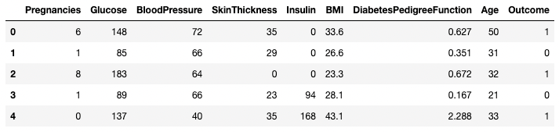

.head() outputs the first five rows of your DataFrame by default, but we could also pass a number as well: df.head(10) would output the top ten rows, for example.

To see the last five rows use .tail(). tail() also accepts a number, and in this case we printing the bottom two rows.:
df.tail(10)
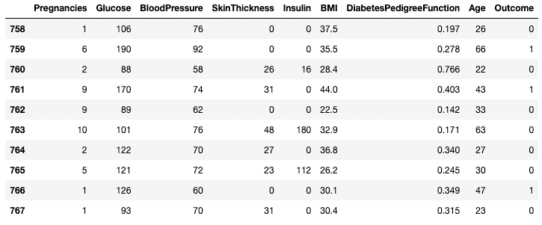

Typically when we load in a dataset, we like to view the first five or so rows to see what's under the hood. Here we can see the names of each column, the index, and examples of values in each row.
You'll notice that the index in our DataFrame is the Title column, which you can tell by how the word Title is slightly lower than the rest of the columns.

- Getting info about your data:
.info() should be one of the very first commands you run after loading your data
df.info(show_counts=True, memory_usage=True, verbose=True)

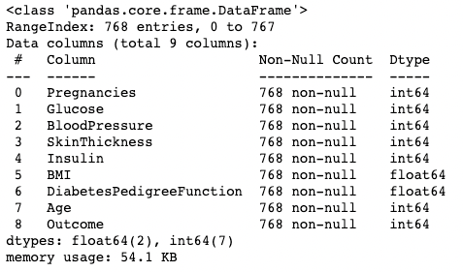

.info() provides the essential details about your dataset, such as the number of rows and columns, the number of non-null values, what type of data is in each column, and how much memory your DataFrame is using.

- Understanding your data using .shape:
The number of rows and columns of a DataFrame can be identified using the .shape attribute of the DataFrame. It returns a tuple (row, column) and can be indexed to get only rows, and only columns count as output.
df.shape # Get the number of rows and columns
df.shape[0] # Get the number of rows only
df.shape[1] # Get the number of columns only
Output:
(768,9)
768
9
- Get all columns and column names:
Calling the .columns attribute of a DataFrame object returns the column names in the form of an Index object. As a reminder, a pandas index is the address/label of the row or column
df.columns
Output:

- Checking for missing values in pandas with .isnull()
You can check whether each element in a DataFrame is missing using the .isnull() method.
df2.isnull().head(7)
Given it's often more useful to know how much missing data you have, you can combine .isnull() with .sum() to count the number of nulls in each column.
df2.isnull().sum()

Pregnancies 4
Glucose 0
BloodPressure 0
SkinThickness 0
Insulin 0
BMI 0
DiabetesPedigreeFunction 0
Age 0
Outcome 0
dtype: int64

- Slicing and Extracting Data in pandas:
The pandas package offers several ways to subset, filter, and isolate data in your DataFrames.
- Isolating one column using [ ]:
You can isolate a single column using a square bracket [ ] with a column name in it. The output is a pandas Series object. A pandas Series is a one-dimensional array containing data of any type, including integer, float, string, boolean, python objects, etc. A DataFrame is comprised of many series that act as columns.
df['Outcome']
Output:
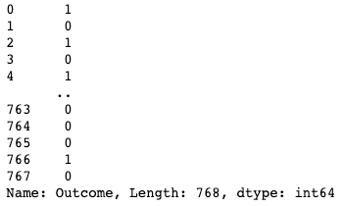

- Isolating two or more columns using [[ ]]:
You can also provide a list of column names inside the square brackets to fetch more than one column. Here, square brackets are used in two different ways. We use the outer square brackets to indicate a subset of a DataFrame, and the inner square brackets to create a list.
df[['Pregnancies', 'Outcome']]
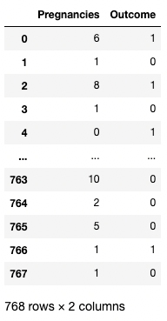

- Isolating one row using [ ]:
A single row can be fetched by passing in a boolean series with one True value. In the example below, the second row with index = 1 is returned. Here, .index returns the row labels of the DataFrame, and the comparison turns that into a Boolean one-dimensional array.
df[df.index==1]
Output:

- Isolating two or more rows using [ ]:

Similarly, two or more rows can be returned using the .isin() method instead of a == operator.

df[df.index.isin(range(2,10))]
Output:
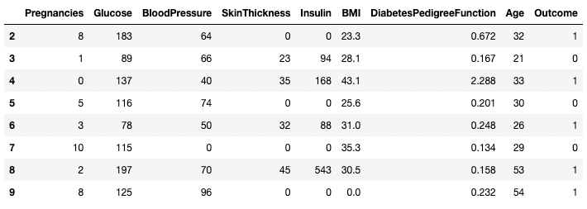

- Using .loc[] and .iloc[] to fetch rows:
You can fetch specific rows by labels or conditions using .loc[] and .iloc[] ("location" and "integer location"). .loc[] uses a label to point to a row, column or cell, whereas .iloc[] uses the numeric position.
- df2.loc[1]
Output:
Pregnancies 6.000
Glucose 148.000
BloodPressure 72.000
SkinThickness 35.000
Insulin 0.000
BMI 33.600
DiabetesPedigreeFunction 0.627
Age 50.000
Outcome 1.000
Name: 1, dtype: float64

- df2.iloc[1]
Output:
Pregnancies 1.000
Glucose 85.000
BloodPressure 66.000
SkinThickness 29.000
Insulin 0.000
BMI 26.600
DiabetesPedigreeFunction 0.351
Age 31.000
Outcome 0.000
Name: 2, dtype: float64
You can also fetch multiple rows by providing a range in square brackets.
df2.loc[100:110]
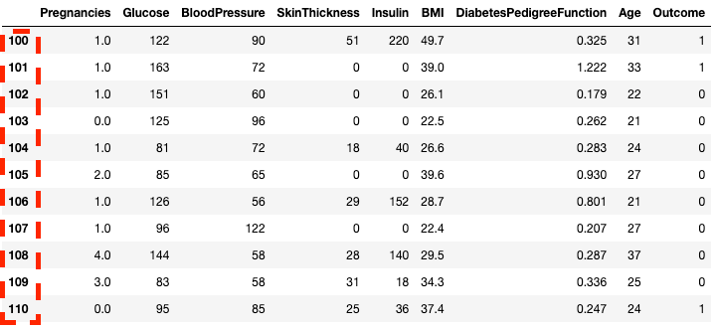

df2.iloc[100:110]
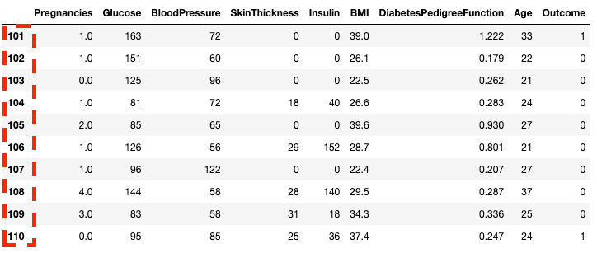

You can also subset with .loc[] and .iloc[] by using a list instead of a range.
df2.loc[[100, 200, 300]]
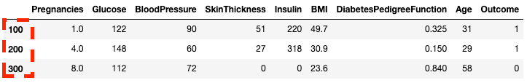

df2.iloc[[100, 200, 300]]
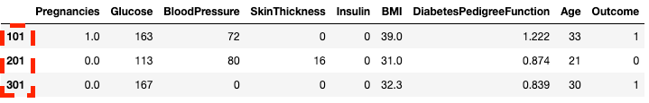

- Conditional slicing (that fits certain conditions):
pandas lets you filter data by conditions over row/column values.
df[df.BloodPressure == 122]
Output:

- Cleaning data using pandas
Data cleaning is one of the most common tasks in data science.
To illustrate a few data cleaning use cases. As a reminder, here's how you can see how many missing values are in a DataFrame.
df2.isnull().sum()
Output:
Pregnancies 4
Glucose 0
BloodPressure 0
SkinThickness 0
Insulin 0
BMI 0
DiabetesPedigreeFunction 0
Age 0
Outcome 0
dtype: int64

    - Dealing with missing data technique #1: Dropping missing values
One way to deal with missing data is to drop it. This is particularly useful in cases where you have plenty of data and losing a small portion won’t impact the downstream analysis. You can use a .dropna() method as shown below.
df3 = df3.dropna()
    - Dealing with missing data technique #2: Replacing missing values
Instead of dropping, replacing missing values with a summary statistic or a specific value (depending on the use case) maybe the best way to go. For example, if there is one missing row from a temperature column denoting temperatures throughout the days of the week, replacing that missing value with the average temperature of that week may be more effective than dropping values completely. You can replace the missing data with the row, or column mean using the code below.
# Get the mean of Pregnancies
mean_value = df3['Pregnancies'].mean()
# Fill missing values using .fillna()
df3 = df3.fillna(mean_value)

    - Dealing with Duplicate Data
You can remove all duplicate rows (default) from the DataFrame using .drop_duplicates() method.
df3 = df3.drop_duplicates()
    - Renaming columns
A common data cleaning task is renaming columns. With the .rename() method, you can use columns as an argument to rename specific columns. The below code shows the dictionary for mapping old and new column names.
df3.rename(columns = {'DiabetesPedigreeFunction':'DPF'}, inplace = True)

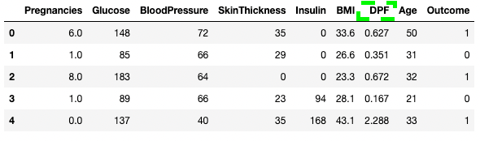

- Data analysis in pandas

The main value proposition of pandas lies in its quick data analysis functionality
- Summary operators (mean, mode, median):
df.mean()
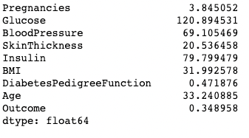

A mode can be computed similarly using the .mode() method.
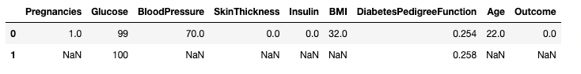
df.mode()

Similarly, the median of each column is computed with the .median() method
df.median()
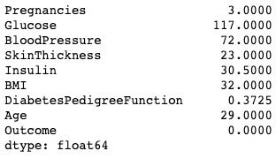

- Create new columns based on existing columns
pandas provides fast and efficient computation by combining two or more columns like scalar variables. The below code divides each value in the column Glucose with the corresponding value in the Insulin column to compute a new column named Glucose_Insulin_Ratio.
df2['Glucose_Insulin_Ratio'] = df2['Glucose']/df2['Insulin']
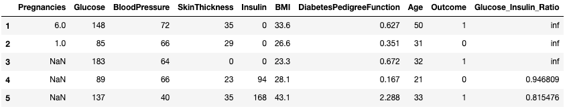
df2.head()

- Counting using .value_counts()
Often times you'll work with categorical values, and you'll want to count the number of observations each category has in a column. Category values can be counted using the .value_counts() methods. Here, for example, we are counting the number of observations where Outcome is diabetic (1) and the number of observations where the Outcome is non-diabetic (0).
df['Outcome'].value_counts()
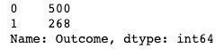

- Aggregating data with .groupby() in pandas
pandas lets you aggregate values by grouping them by specific column values. You can do that by combining the .groupby() method with a summary method of your choice. The below code displays the mean of each of the numeric columns grouped by Outcome.
df.groupby('Outcome').mean()
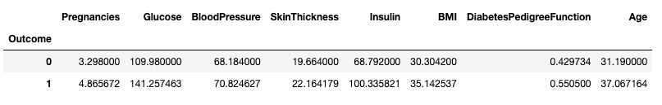
Matplotlib
- Matplotlib is the basic plotting library of Python programming language. It is the most prominent tool among Python visualization packages. Matplotlib is highly efficient in performing wide range of tasks. It can produce publication quality figures in a variety of formats.
- It can export visualizations to all of the common formats like PDF, SVG, JPG, PNG, BMP and GIF.
- It can create popular visualization types – line plot, scatter plot, histogram, bar chart, error charts, pie chart, box plot, and many more types of plot.
- Matplotlib also supports 3D plotting.
- Many Python libraries are built on top of Matplotlib. For example, pandas and Seaborn are built on Matplotlib.

- Installation of Matplotlib:

pip install matplotlib

- Import Matplotlib:

Before, we need to actually start using Matplotlib, we need to import it. We can import Matplotlib as follows:-

import matplotlib

Most of the time, we have to work with pyplot interface of Matplotlib. So, I will import pyplot interface of Matplotlib as follows:-

import matplotlib.pyplot

To make things even simpler, we will use standard shorthand for Matplotlib imports as follows:-

import matplotlib.pyplot as plt

- Displaying Plots in Matplotlib:
The general steps to draw a chart using Matplotlib:
- Import Matplotlib: Import the matplotlib.pyplot module, usually imported as plt, which provides a MATLAB-like plotting interface.
- Prepare your data: Define the data you want to visualize. This could be in the form of lists, NumPy arrays, or data loaded from files or databases.
- Create a plot: Use Matplotlib functions to create the desired type of plot. Matplotlib provides functions like plot(), scatter(), bar(), hist(), etc., for different types of plots.
- Customize the plot: Customize various aspects of the plot such as labels, titles, colors, line styles, markers, etc., using Matplotlib functions.
- Show the plot: Use plt.show() to display the plot. This will open a new window with the plot or display it inline depending on your environment setup.
Example:
import matplotlib.pyplot as plt
# Step 2: Prepare data
x = [1, 2, 3, 4, 5]
y = [2, 3, 5, 7, 11]
# Step 3: Create a plot
plt.plot(x, y)
# Step 4: Customize the plot
plt.xlabel('X-axis')
plt.ylabel('Y-axis')
plt.title('Simple Line Plot')
# Step 5: Show the plot
plt.show()

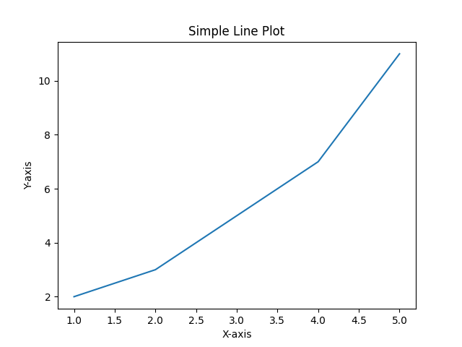
Output:

- Formatting a Plot:

- Markers:
We can use the keyword argument marker to emphasize each point with a specified marker:

import matplotlib.pyplot as plt
import numpy as np

ypoints = np.array([3, 8, 1, 10])

plt.plot(ypoints, marker = 'o')
plt.show()

Output:
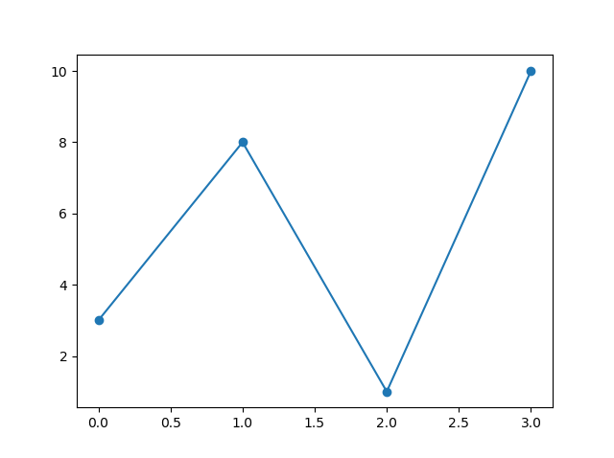

- Linestyle:
You can use the keyword argument linestyle, or shorter ls, to change the style of the plotted line:

import matplotlib.pyplot as plt
import numpy as np
ypoints = np.array([3, 8, 1, 10])
plt.plot(ypoints, linestyle = 'dotted')
plt.show()
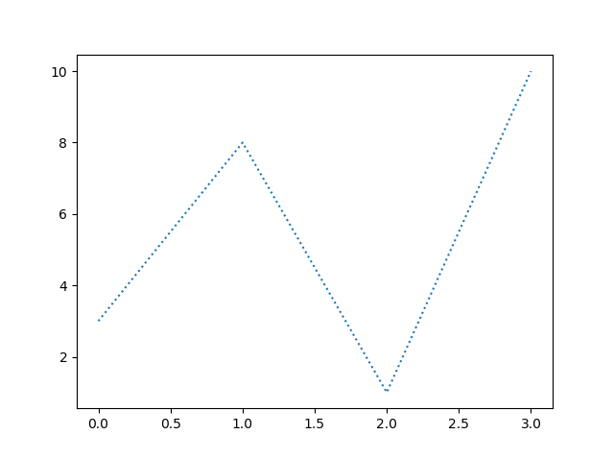

- Create Labels for a Plot:
With Pyplot, you can use the xlabel() and ylabel() functions to set a label for the x- and y-axis.
import numpy as np
import matplotlib.pyplot as plt

x = np.array([80, 85, 90, 95, 100, 105, 110, 115, 120, 125])
y = np.array([240, 250, 260, 270, 280, 290, 300, 310, 320, 330])

plt.plot(x, y)
plt.xlabel("Average Pulse")
plt.ylabel("Calorie Burnage")
plt.show()

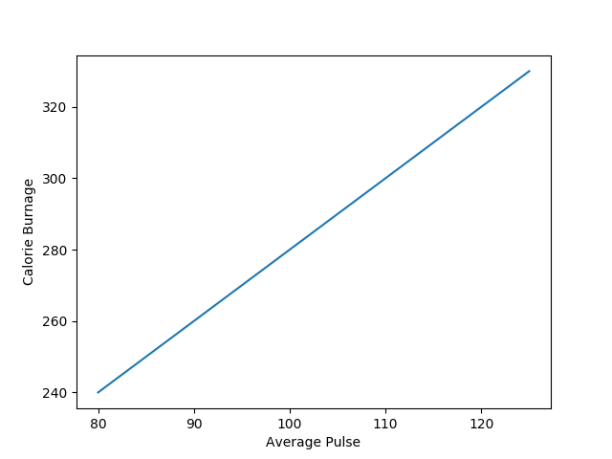

- Add Grid Lines to a Plot:
With Pyplot, you can use the grid() function to add grid lines to the plot.
import numpy as np
import matplotlib.pyplot as plt

x = np.array([80, 85, 90, 95, 100, 105, 110, 115, 120, 125])
y = np.array([240, 250, 260, 270, 280, 290, 300, 310, 320, 330])

plt.title("Sports Watch Data")
plt.xlabel("Average Pulse")
plt.ylabel("Calorie Burnage")
plt.plot(x, y)

plt.grid()
plt.show()

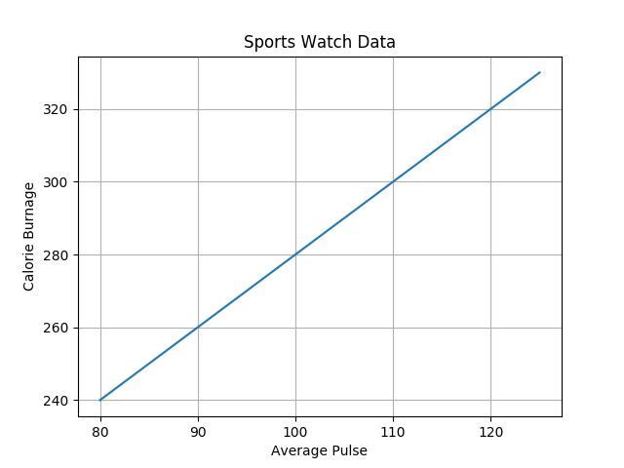

- Display Multiple Plots:
With the subplot() function you can draw multiple plots in one figure:
import matplotlib.pyplot as plt
import numpy as np
#plot 1:
x = np.array([0, 1, 2, 3])
y = np.array([3, 8, 1, 10])
plt.subplot(1, 2, 1)
plt.plot(x,y)
#plot 2:
x = np.array([0, 1, 2, 3])
y = np.array([10, 20, 30, 40])
plt.subplot(1, 2, 2)
plt.plot(x,y)
plt.show()

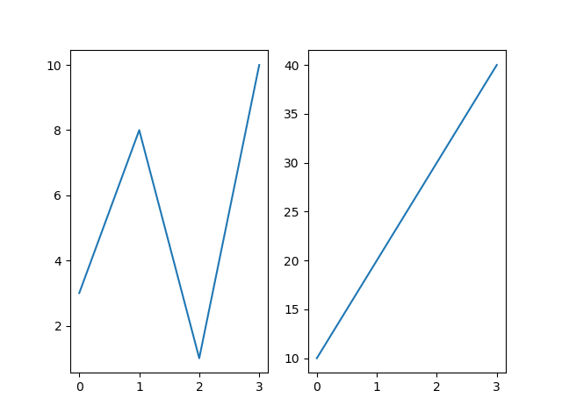

- Creating Scatter Plots:
With Pyplot, you can use the scatter() function to draw a scatter plot.
The scatter() function plots one dot for each observation. It needs two arrays of the same length, one for the values of the x-axis, and one for values on the y-axis:
import matplotlib.pyplot as plt
import numpy as np

x = np.array([5,7,8,7,2,17,2,9,4,11,12,9,6])
y = np.array([99,86,87,88,111,86,103,87,94,78,77,85,86])

plt.scatter(x, y)
plt.show()

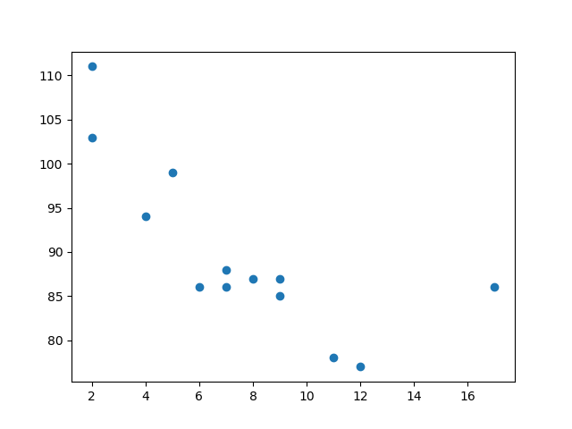

- Creating Bars:
With Pyplot, you can use the bar() function to draw bar graphs:

import matplotlib.pyplot as plt
import numpy as np

x = np.array(["A", "B", "C", "D"])
y = np.array([3, 8, 1, 10])

plt.bar(x,y)
plt.show()

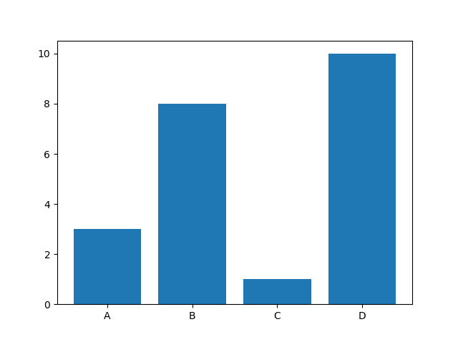

- Horizontal Bars:
If you want the bars to be displayed horizontally instead of vertically, use the barh() function:
import matplotlib.pyplot as plt
import numpy as np

x = np.array(["A", "B", "C", "D"])
y = np.array([3, 8, 1, 10])

plt.barh(x, y)
plt.show()

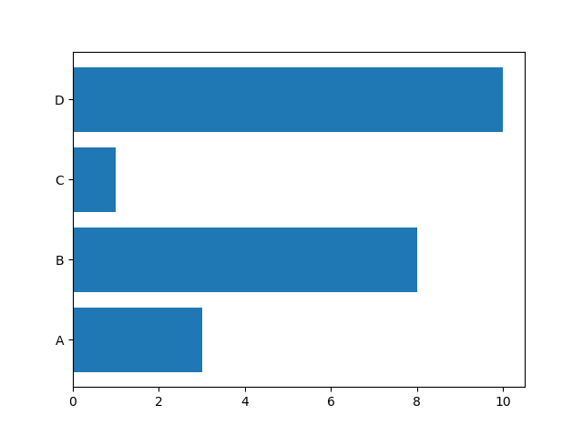

- Histogram:
A histogram is a graph showing frequency distributions.
It is a graph showing the number of observations within each given interval.
Example: Say you ask for the height of 250 people, you might end up with a histogram like this:
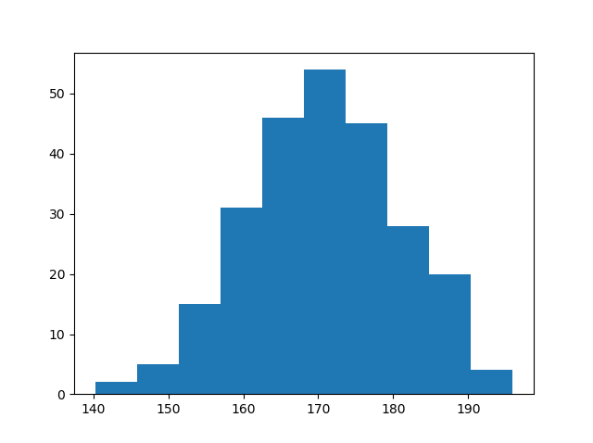

You can read from the histogram that there are approximately:

2 people from 140 to 145cm
5 people from 145 to 150cm
15 people from 151 to 156cm
31 people from 157 to 162cm
46 people from 163 to 168cm
53 people from 168 to 173cm
45 people from 173 to 178cm
28 people from 179 to 184cm
21 people from 185 to 190cm
4 people from 190 to 195cm

Example:
import matplotlib.pyplot as plt
import numpy as np

x = np.random.normal(170, 10, 250)

plt.hist(x)
plt.show()


- Creating Pie Charts:
With Pyplot, you can use the pie() function to draw pie charts:
import matplotlib.pyplot as plt
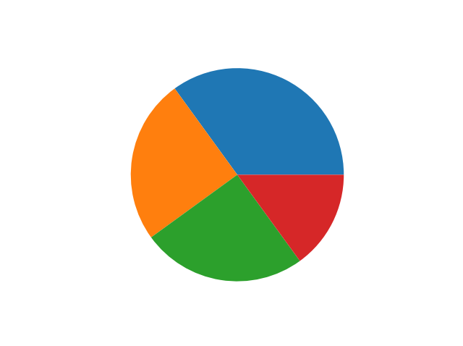
import numpy as np

y = np.array([35, 25, 25, 15])

plt.pie(y)
plt.show()

Add labels to the pie chart with the labels parameter.
The labels parameter must be an array with one label for each wedge:

import matplotlib.pyplot as plt
import numpy as np

y = np.array([35, 25, 25, 15])
mylabels = ["Apples", "Bananas", "Cherries", "Dates"]

plt.pie(y, labels = mylabels)
plt.show()
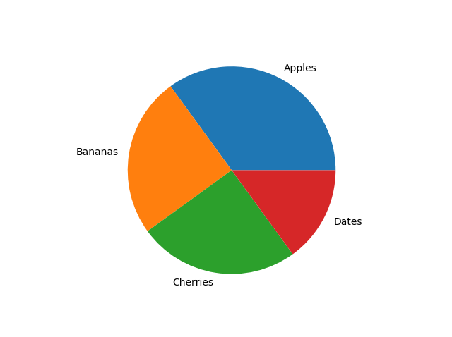

- Creating Line Charts:
Creating a line chart in Matplotlib is quite simple. You can use the plt.plot() function to draw lines connecting points defined by the provided x and y coordinates. Here's a basic example:

Creating a line chart in Matplotlib is quite simple. You can use the plt.plot() function to draw lines connecting points defined by the provided x and y coordinates. Here's a basic example:

import matplotlib.pyplot as plt

# Sample data
x = [1, 2, 3, 4, 5]
y = [2, 3, 5, 7, 11]
# Create a line chart
plt.plot(x, y)
# Add labels and title
plt.xlabel('X-axis')
plt.ylabel('Y-axis')
plt.title('Line Chart')
# Display the plot
plt.show()

In this example:
- plt.plot(x, y) creates a line chart with points specified by the lists x and y. Matplotlib automatically connects these points with lines.
- plt.xlabel('X-axis') and plt.ylabel('Y-axis') set labels for the x-axis and y-axis respectively.
- plt.title('Line Chart') sets the title of the plot.
- plt.show() displays the plot.

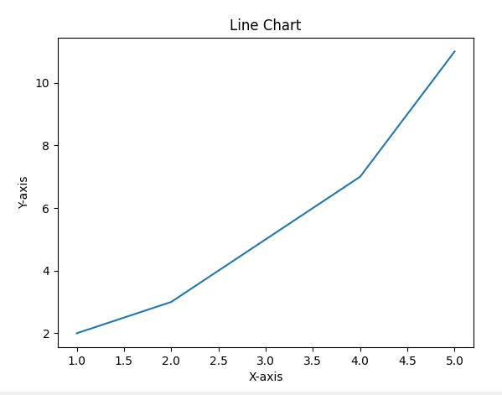

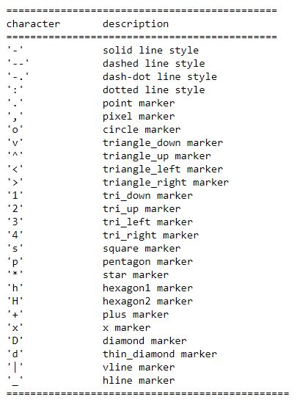
- The format parameter of pyplot.plot

The following color abbreviations are supported:
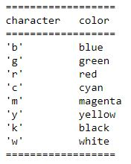

Example:
# evenly sampled time at 200ms intervals
t = np.arange(0., 5., 0.2)

# red dashes, blue squares and green triangles
plt.plot(t, t, 'r--', t, t**2, 'bs', t, t**3, 'g^')
plt.show()
